NAME | CHRISTOPHER LLANDER L. VILLACINO
PROJECT TITLE | ServiFinance: A Multi-Tenant SaaS Service Management System with Embedded Micro-Lending
SUBJECT:  CODE:  TIME: | IT15/L Integrative Programming and Technologies  8466  1:30 – 3:30 PM
TOPIC (Type of Business Process) | #33 Service Management System
Products/Services | SaaS platform for Service-Oriented MSMEs
1st Deliverables
AGILE MODEL: REQUIREMENTS AND PLANNING
Use Case Diagram  (Updated) | 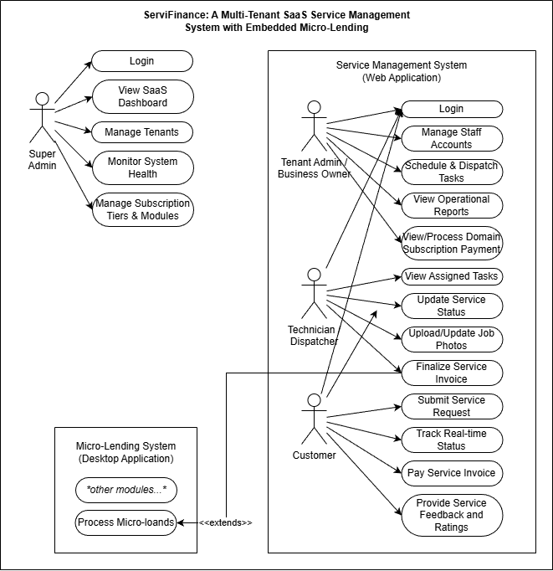
Entity Relational Diagram | 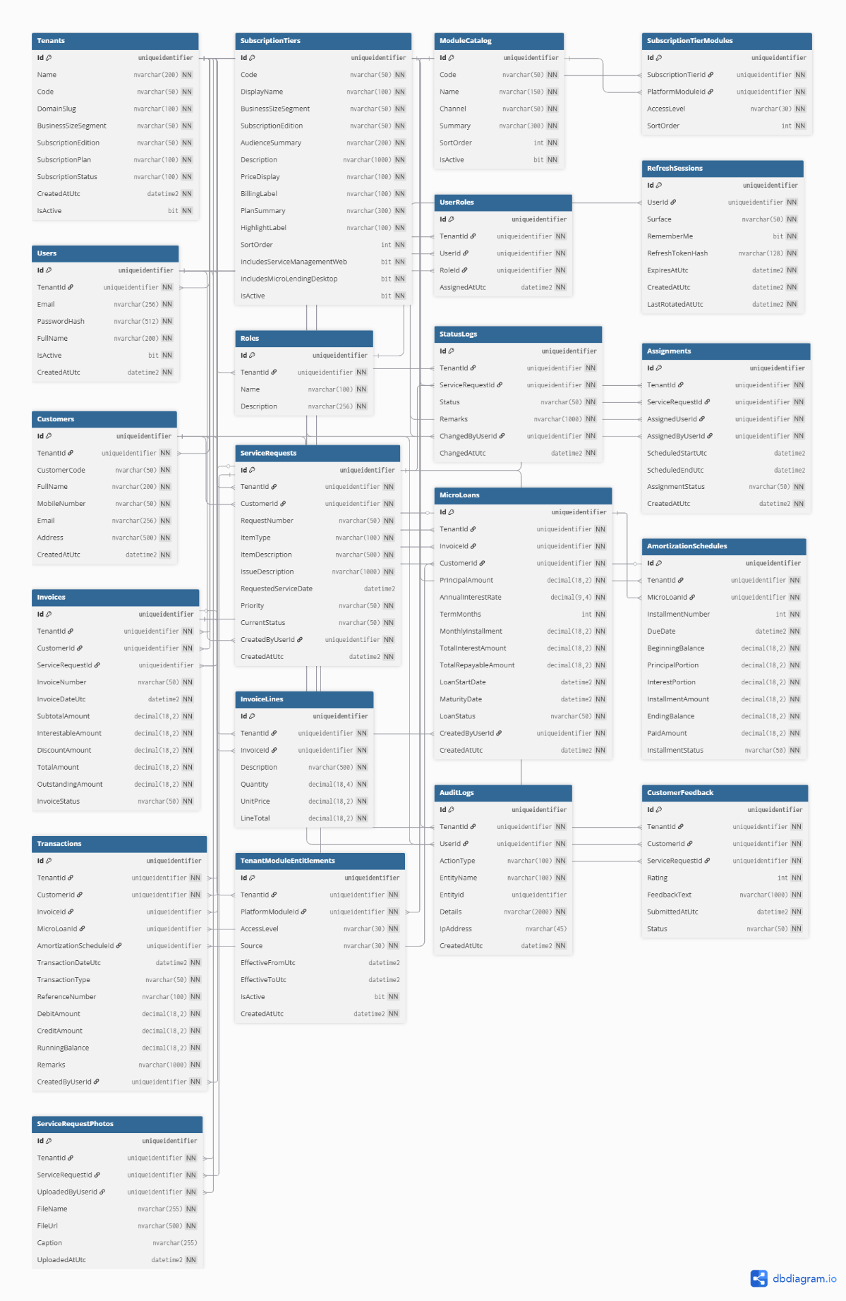
Data Dictionary | ServiFinance: A Multi-Tenant SaaS Service Management System with Embedded Micro-Lending  Level 1 - Super Admin  Tenants table  Field Names Datatype Length Description  Id uniqueidentifier 36 Primary key of the tenant record  Name nvarchar 200 Tenant or business display name  Code nvarchar 50 Unique business code used by the platform  DomainSlug nvarchar 100 Unique route slug used for tenant URLs  BusinessSizeSegment nvarchar 50 MSME size segment such as Micro, Small, or Medium  SubscriptionEdition nvarchar 50 Product edition such as Standard or Premium  SubscriptionPlan nvarchar 100 Commercial plan label for the tenant  SubscriptionStatus nvarchar 100 Current subscription lifecycle state  CreatedAtUtc datetime2 - UTC date and time when the tenant was created  IsActive bit 1 Active or inactive status of the tenant  SubscriptionTiers table  Field Names Datatype Length Description  Id uniqueidentifier 36 Primary key of the subscription tier  Code nvarchar 50 Unique catalog code of the tier  DisplayName nvarchar 100 User-facing name of the tier  BusinessSizeSegment nvarchar 50 MSME segment covered by the tier  SubscriptionEdition nvarchar 50 Edition covered by the tier  AudienceSummary nvarchar 200 Short target audience summary  Description nvarchar 1000 Full description of the tier  PriceDisplay nvarchar 100 Price label shown in the UI  BillingLabel nvarchar 100 Billing period or billing note  PlanSummary nvarchar 300 Short summary of plan inclusions  HighlightLabel nvarchar 100 Badge or marketing highlight label  SortOrder int 10 Display order in the catalog  IncludesServiceManagementWeb bit 1 Indicates if the web service module is included  IncludesMicroLendingDesktop bit 1 Indicates if the desktop lending module is included  IsActive bit 1 Active or inactive catalog state  ModuleCatalog table  Field Names Datatype Length Description  Id uniqueidentifier 36 Primary key of the module catalog row  Code nvarchar 50 Unique module code such as W1 or D1  Name nvarchar 150 Module name shown to operators  Channel nvarchar 50 Delivery channel such as Web or Desktop  Summary nvarchar 300 Short purpose statement of the module  SortOrder int 10 Display order in the module catalog  IsActive bit 1 Active or inactive catalog state  SubscriptionTierModules table  Field Names Datatype Length Description  Id uniqueidentifier 36 Primary key of the tier-module mapping  SubscriptionTierId uniqueidentifier 36 Foreign key to `SubscriptionTiers.Id`  PlatformModuleId uniqueidentifier 36 Foreign key to `ModuleCatalog.Id`  AccessLevel nvarchar 30 Access rule such as Included, Limited, or Not Included  SortOrder int 10 Display order within the tier mapping  Users table  Field Names Datatype Length Description  Id uniqueidentifier 36 Primary key of the user account  TenantId uniqueidentifier 36 Foreign key to `Tenants.Id`; platform superadmins use the reserved platform tenant  Email nvarchar 256 Login email address of the user  PasswordHash nvarchar 512 Hashed password value  FullName nvarchar 200 Full name of the user  IsActive bit 1 Active or inactive status of the account  CreatedAtUtc datetime2 - UTC date and time when the account was created  Roles table  Field Names Datatype Length Description  Id uniqueidentifier 36 Primary key of the role  TenantId uniqueidentifier 36 Foreign key to `Tenants.Id`  Name nvarchar 100 Role name such as SuperAdmin, Administrator, or Staff  Description nvarchar 256 Short description of the role purpose  UserRoles table  Field Names Datatype Length Description  Id uniqueidentifier 36 Primary key of the role assignment  TenantId uniqueidentifier 36 Foreign key to `Tenants.Id`  UserId uniqueidentifier 36 Foreign key to `Users.Id`  RoleId uniqueidentifier 36 Foreign key to `Roles.Id`  AssignedAtUtc datetime2 - UTC date and time when the role was assigned  RefreshSessions table  Field Names Datatype Length Description  Id uniqueidentifier 36 Primary key of the refresh session  UserId uniqueidentifier 36 Foreign key to `Users.Id`  Surface nvarchar 50 Client surface such as web or desktop  RememberMe bit 1 Indicates whether a persistent session was requested  RefreshTokenHash nvarchar 128 Unique hash of the refresh token  ExpiresAtUtc datetime2 - UTC date and time when the refresh session expires  CreatedAtUtc datetime2 - UTC date and time when the session was issued  LastRotatedAtUtc datetime2 - UTC date and time when the refresh token was last rotated  TenantModuleEntitlements table  Field Names Datatype Length Description  Id uniqueidentifier 36 Primary key of the tenant-specific module entitlement  TenantId uniqueidentifier 36 Foreign key to `Tenants.Id`  PlatformModuleId uniqueidentifier 36 Foreign key to `ModuleCatalog.Id`  AccessLevel nvarchar 30 Effective access level for the tenant  Source nvarchar 30 Entitlement source such as tier-default, override, or promo  EffectiveFromUtc datetime2 - Optional start date of the entitlement  EffectiveToUtc datetime2 - Optional end date of the entitlement  IsActive bit 1 Indicates whether the entitlement is currently active  CreatedAtUtc datetime2 - UTC date and time when the entitlement was recorded  AuditLogs table  Field Names Datatype Length Description  Id uniqueidentifier 36 Primary key of the audit log record  TenantId uniqueidentifier 36 Foreign key to `Tenants.Id`  UserId uniqueidentifier 36 Foreign key to `Users.Id` for the actor  ActionType nvarchar 100 Action category such as Login, ProvisionTenant, or UpdateRole  EntityName nvarchar 100 Name of the affected table or business entity  EntityId uniqueidentifier 36 Identifier of the affected record when applicable  Details nvarchar 2000 Full audit details or serialized change summary  IpAddress nvarchar 45 Source IP address if captured  CreatedAtUtc datetime2 - UTC date and time when the action happened  Level 2 - Tenant Administrator / Owner  Users table (*refer to Level 1 – Super Admin)  Roles table (*refer to Level 1 – Super Admin)  UserRoles table (*refer to Level 1 – Super Admin)  Customers table  Field Names Datatype Length Description  Id uniqueidentifier 36 Primary key of the customer  TenantId uniqueidentifier 36 Foreign key to `Tenants.Id`  CustomerCode nvarchar 50 Unique customer code within the tenant  FullName nvarchar 200 Full name of the customer  MobileNumber nvarchar 50 Mobile or contact number  Email nvarchar 256 Customer email address  Address nvarchar 500 Customer address  CreatedAtUtc datetime2 - UTC date and time when the customer was registered  ServiceRequests table  Field Names Datatype Length Description  Id uniqueidentifier 36 Primary key of the service request  TenantId uniqueidentifier 36 Foreign key to `Tenants.Id`  CustomerId uniqueidentifier 36 Foreign key to `Customers.Id`  RequestNumber nvarchar 50 Unique service request number within the tenant  ItemType nvarchar 100 General item type, such as oven or laptop  ItemDescription nvarchar 500 Detailed description of the service item  IssueDescription nvarchar 1000 Customer-reported issue or complaint  RequestedServiceDate datetime2 - Requested service schedule, if provided  Priority nvarchar 50 Priority level of the request  CurrentStatus nvarchar 50 Current workflow status of the request  CreatedByUserId uniqueidentifier 36 Foreign key to `Users.Id` for the creator  CreatedAtUtc datetime2 - UTC date and time when the request was created  StatusLogs table  Field Names Datatype Length Description  Id uniqueidentifier 36 Primary key of the status log  TenantId uniqueidentifier 36 Foreign key to `Tenants.Id`  ServiceRequestId uniqueidentifier 36 Foreign key to `ServiceRequests.Id`  Status nvarchar 50 Status value recorded for the request  Remarks nvarchar 1000 Remarks or explanation of the status change  ChangedByUserId uniqueidentifier 36 Foreign key to `Users.Id` for the operator who changed the status  ChangedAtUtc datetime2 - UTC date and time when the status changed  Assignments table  Field Names Datatype Length Description  Id uniqueidentifier 36 Primary key of the assignment  TenantId uniqueidentifier 36 Foreign key to `Tenants.Id`  ServiceRequestId uniqueidentifier 36 Foreign key to `ServiceRequests.Id`  AssignedUserId uniqueidentifier 36 Foreign key to `Users.Id` for the assigned staff member  AssignedByUserId uniqueidentifier 36 Foreign key to `Users.Id` for the assigning manager  ScheduledStartUtc datetime2 - Planned start date and time  ScheduledEndUtc datetime2 - Planned end date and time  AssignmentStatus nvarchar 50 Current status of the assignment  CreatedAtUtc datetime2 - UTC date and time when the assignment was created  Invoices table  Field Names Datatype Length Description  Id uniqueidentifier 36 Primary key of the invoice  TenantId uniqueidentifier 36 Foreign key to `Tenants.Id`  CustomerId uniqueidentifier 36 Foreign key to `Customers.Id`  ServiceRequestId uniqueidentifier 36 Optional foreign key to `ServiceRequests.Id`  InvoiceNumber nvarchar 50 Unique invoice number within the tenant  InvoiceDateUtc datetime2 - UTC date and time of invoice issuance  SubtotalAmount decimal 18,2 Sum of invoice line amounts before discount and loan handling  InterestableAmount decimal 18,2 Amount eligible for financing or interest  DiscountAmount decimal 18,2 Discount amount applied to the invoice  TotalAmount decimal 18,2 Final total amount due  OutstandingAmount decimal 18,2 Remaining unpaid amount  InvoiceStatus nvarchar 50 Status of the invoice, such as Open or Paid  InvoiceLines table  Field Names Datatype Length Description  Id uniqueidentifier 36 Primary key of the invoice line  TenantId uniqueidentifier 36 Foreign key to `Tenants.Id`  InvoiceId uniqueidentifier 36 Foreign key to `Invoices.Id`  Description nvarchar 500 Description of the billed item or service  Quantity decimal 18,4 Quantity billed on the line  UnitPrice decimal 18,2 Unit price of the line item  LineTotal decimal 18,2 Extended amount of the line item  MicroLoans table (Desktop side)  Field Names Datatype Length Description  Id uniqueidentifier 36 Primary key of the micro-loan  TenantId uniqueidentifier 36 Foreign key to `Tenants.Id`  InvoiceId uniqueidentifier 36 Foreign key to `Invoices.Id`; one invoice can produce at most one loan  CustomerId uniqueidentifier 36 Foreign key to `Customers.Id`  PrincipalAmount decimal 18,2 Loan principal amount  AnnualInterestRate decimal 9,4 Annual interest rate used for computation  TermMonths int 10 Loan term in months  MonthlyInstallment decimal 18,2 Fixed installment amount per month  TotalInterestAmount decimal 18,2 Total interest for the whole loan  TotalRepayableAmount decimal 18,2 Total amount to be repaid  LoanStartDate datetime2 - Start date of the loan  MaturityDate datetime2 - Final due date of the loan  LoanStatus nvarchar 50 Current status of the loan  CreatedByUserId uniqueidentifier 36 Foreign key to `Users.Id` for the creating operator  CreatedAtUtc datetime2 - UTC date and time when the loan was created  AmortizationSchedules table (Desktop side)  Field Names Datatype Length Description  Id uniqueidentifier 36 Primary key of the amortization row  TenantId uniqueidentifier 36 Foreign key to `Tenants.Id`  MicroLoanId uniqueidentifier 36 Foreign key to `MicroLoans.Id`  InstallmentNumber int 10 Sequence number of the installment  DueDate datetime2 - Due date of the installment  BeginningBalance decimal 18,2 Loan balance before the installment  PrincipalPortion decimal 18,2 Principal amount included in the installment  InterestPortion decimal 18,2 Interest amount included in the installment  InstallmentAmount decimal 18,2 Total installment amount due  EndingBalance decimal 18,2 Balance after the installment  PaidAmount decimal 18,2 Amount already paid against the installment  InstallmentStatus nvarchar 50 Status of the installment, such as Unpaid, Partial, or Paid  Transactions table  Field Names Datatype Length Description  Id uniqueidentifier 36 Primary key of the ledger transaction  TenantId uniqueidentifier 36 Foreign key to `Tenants.Id`  CustomerId uniqueidentifier 36 Foreign key to `Customers.Id`  InvoiceId uniqueidentifier 36 Optional foreign key to `Invoices.Id`  MicroLoanId uniqueidentifier 36 Optional foreign key to `MicroLoans.Id`  AmortizationScheduleId uniqueidentifier 36 Optional foreign key to `AmortizationSchedules.Id`  TransactionDateUtc datetime2 - UTC date and time of the ledger event  TransactionType nvarchar 50 Type of ledger event, such as Invoice, Loan, or Payment  ReferenceNumber nvarchar 100 Human-readable transaction reference  DebitAmount decimal 18,2 Debit amount recorded in the ledger  CreditAmount decimal 18,2 Credit amount recorded in the ledger  RunningBalance decimal 18,2 Balance after the transaction posting  Remarks nvarchar 1000 Transaction remarks or explanation  CreatedByUserId uniqueidentifier 36 Foreign key to `Users.Id` for the creating operator  CustomerFeedback table  Field Names Datatype Length Description  Id uniqueidentifier 36 Primary key of the customer feedback record  TenantId uniqueidentifier 36 Foreign key to `Tenants.Id`  CustomerId uniqueidentifier 36 Foreign key to `Customers.Id`  ServiceRequestId uniqueidentifier 36 Foreign key to `ServiceRequests.Id`  Rating int 10 Numeric service rating submitted by the customer  FeedbackText nvarchar 1000 Comment or feedback text  SubmittedAtUtc datetime2 - UTC date and time when feedback was submitted  Status nvarchar 50 Review status of the feedback  ServiceRequestPhotos table  Field Names Datatype Length Description  Id uniqueidentifier 36 Primary key of the service request photo record  TenantId uniqueidentifier 36 Foreign key to `Tenants.Id`  ServiceRequestId uniqueidentifier 36 Foreign key to `ServiceRequests.Id`  UploadedByUserId uniqueidentifier 36 Foreign key to `Users.Id` for the uploader  FileName nvarchar 255 Original or stored file name  FileUrl nvarchar 500 File path or blob URL of the uploaded image  Caption nvarchar 255 Optional caption or note for the image  UploadedAtUtc datetime2 - UTC date and time when the image was uploaded  Level 3 - Service Staff / Technician  Customers table  Field Names Datatype Length Description  Id uniqueidentifier 36 Primary key of the customer  TenantId uniqueidentifier 36 Foreign key to `Tenants.Id`  CustomerCode nvarchar 50 Unique customer code within the tenant  FullName nvarchar 200 Customer full name  MobileNumber nvarchar 50 Contact number used for service coordination  Email nvarchar 256 Customer email address  Address nvarchar 500 Customer address  CreatedAtUtc datetime2 - UTC date and time when the customer was added  ServiceRequests table  Field Names Datatype Length Description  Id uniqueidentifier 36 Primary key of the service request  TenantId uniqueidentifier 36 Foreign key to `Tenants.Id`  CustomerId uniqueidentifier 36 Foreign key to `Customers.Id`  RequestNumber nvarchar 50 Unique service request number  ItemType nvarchar 100 Category of the service item  ItemDescription nvarchar 500 Description of the item being serviced  IssueDescription nvarchar 1000 Reported issue of the item  RequestedServiceDate datetime2 - Requested schedule of service  Priority nvarchar 50 Request priority  CurrentStatus nvarchar 50 Current work status  CreatedByUserId uniqueidentifier 36 User who created the request  CreatedAtUtc datetime2 - UTC date and time when the request was created  StatusLogs table  Field Names Datatype Length Description  Id uniqueidentifier 36 Primary key of the status update row  TenantId uniqueidentifier 36 Foreign key to `Tenants.Id`  ServiceRequestId uniqueidentifier 36 Foreign key to `ServiceRequests.Id`  Status nvarchar 50 Updated service status  Remarks nvarchar 1000 Notes regarding the update  ChangedByUserId uniqueidentifier 36 User who made the update  ChangedAtUtc datetime2 - UTC date and time when the update was posted  Assignments table  Field Names Datatype Length Description  Id uniqueidentifier 36 Primary key of the assignment row  TenantId uniqueidentifier 36 Foreign key to `Tenants.Id`  ServiceRequestId uniqueidentifier 36 Foreign key to `ServiceRequests.Id`  AssignedUserId uniqueidentifier 36 Technician or staff assigned to the task  AssignedByUserId uniqueidentifier 36 User who created the assignment  ScheduledStartUtc datetime2 - Planned start schedule  ScheduledEndUtc datetime2 - Planned completion schedule  AssignmentStatus nvarchar 50 Current assignment status  CreatedAtUtc datetime2 - UTC date and time when the assignment was logged  ServiceRequestPhotos table  Field Names Datatype Length Description  Id uniqueidentifier 36 Primary key of the service photo row  TenantId uniqueidentifier 36 Foreign key to `Tenants.Id`  ServiceRequestId uniqueidentifier 36 Foreign key to `ServiceRequests.Id`  UploadedByUserId uniqueidentifier 36 Foreign key to `Users.Id`  FileName nvarchar 255 Stored file name of the image  FileUrl nvarchar 500 Path or URL of the image  Caption nvarchar 255 Caption for the service photo  UploadedAtUtc datetime2 - UTC date and time when the photo was uploaded  CustomerFeedback table  Field Names Datatype Length Description  Id uniqueidentifier 36 Primary key of the feedback record  TenantId uniqueidentifier 36 Foreign key to `Tenants.Id`  CustomerId uniqueidentifier 36 Foreign key to `Customers.Id`  ServiceRequestId uniqueidentifier 36 Foreign key to `ServiceRequests.Id`  Rating int 10 Rating submitted by the customer  FeedbackText nvarchar 1000 Written feedback  SubmittedAtUtc datetime2 - UTC date and time when the feedback was submitted  Status nvarchar 50 Internal follow-up status  Level 4 - Finance Staff / Loan Officer / Cashier (Desktop side)  Customers table  Field Names Datatype Length Description  Id uniqueidentifier 36 Primary key of the customer  TenantId uniqueidentifier 36 Foreign key to `Tenants.Id`  CustomerCode nvarchar 50 Unique customer code used in finance and service flows  FullName nvarchar 200 Customer full name  MobileNumber nvarchar 50 Contact number  Email nvarchar 256 Customer email address  Address nvarchar 500 Customer address  CreatedAtUtc datetime2 - UTC date and time when the customer was created  Invoices table  Field Names Datatype Length Description  Id uniqueidentifier 36 Primary key of the invoice  TenantId uniqueidentifier 36 Foreign key to `Tenants.Id`  CustomerId uniqueidentifier 36 Foreign key to `Customers.Id`  ServiceRequestId uniqueidentifier 36 Optional source service request  InvoiceNumber nvarchar 50 Unique invoice number  InvoiceDateUtc datetime2 - Invoice issue date and time  SubtotalAmount decimal 18,2 Total before discounts  InterestableAmount decimal 18,2 Amount eligible for financing  DiscountAmount decimal 18,2 Discount applied to the invoice  TotalAmount decimal 18,2 Final billed amount  OutstandingAmount decimal 18,2 Remaining unpaid balance  InvoiceStatus nvarchar 50 Current invoice status  InvoiceLines table  Field Names Datatype Length Description  Id uniqueidentifier 36 Primary key of the invoice line  TenantId uniqueidentifier 36 Foreign key to `Tenants.Id`  InvoiceId uniqueidentifier 36 Foreign key to `Invoices.Id`  Description nvarchar 500 Billed service or item description  Quantity decimal 18,4 Quantity billed  UnitPrice decimal 18,2 Unit price  LineTotal decimal 18,2 Total amount of the line  MicroLoans table  Field Names Datatype Length Description  Id uniqueidentifier 36 Primary key of the micro-loan  TenantId uniqueidentifier 36 Foreign key to `Tenants.Id`  InvoiceId uniqueidentifier 36 Source invoice converted into a loan  CustomerId uniqueidentifier 36 Foreign key to `Customers.Id`  PrincipalAmount decimal 18,2 Loan principal  AnnualInterestRate decimal 9,4 Annual interest rate  TermMonths int 10 Repayment term in months  MonthlyInstallment decimal 18,2 Monthly amortization amount  TotalInterestAmount decimal 18,2 Total interest value  TotalRepayableAmount decimal 18,2 Principal plus total interest  LoanStartDate datetime2 - Loan start date  MaturityDate datetime2 - Final due date  LoanStatus nvarchar 50 Loan lifecycle status  CreatedByUserId uniqueidentifier 36 User who created the loan  CreatedAtUtc datetime2 - UTC date and time when the loan was created  AmortizationSchedules table  Field Names Datatype Length Description  Id uniqueidentifier 36 Primary key of the amortization row  TenantId uniqueidentifier 36 Foreign key to `Tenants.Id`  MicroLoanId uniqueidentifier 36 Foreign key to `MicroLoans.Id`  InstallmentNumber int 10 Installment sequence number  DueDate datetime2 - Installment due date  BeginningBalance decimal 18,2 Balance before the installment  PrincipalPortion decimal 18,2 Principal component of the installment  InterestPortion decimal 18,2 Interest component of the installment  InstallmentAmount decimal 18,2 Total installment amount  EndingBalance decimal 18,2 Balance after the installment  PaidAmount decimal 18,2 Amount already paid against the row  InstallmentStatus nvarchar 50 Status of the installment  Transactions table (*refer to Level 2 -)  AuditLogs table  Field Names Datatype Length Description  Id uniqueidentifier 36 Primary key of the audit log  TenantId uniqueidentifier 36 Foreign key to `Tenants.Id`  UserId uniqueidentifier 36 User who performed the action  ActionType nvarchar 100 Action being audited  EntityName nvarchar 100 Affected entity or table name  EntityId uniqueidentifier 36 Affected record identifier  Details nvarchar 2000 Change summary or event details  IpAddress nvarchar 45 Client IP address  CreatedAtUtc datetime2 - UTC date and time when the action occurred  Level 5 - Customer / External Client (Future self-service)  Customers table  Field Names Datatype Length Description  Id uniqueidentifier 36 Primary key of the customer profile  TenantId uniqueidentifier 36 Foreign key to `Tenants.Id`  CustomerCode nvarchar 50 Unique customer code  FullName nvarchar 200 Customer full name  MobileNumber nvarchar 50 Customer contact number  Email nvarchar 256 Customer email address  Address nvarchar 500 Customer address  CreatedAtUtc datetime2 - UTC date and time when the customer profile was created  ServiceRequests table  Field Names Datatype Length Description  Id uniqueidentifier 36 Primary key of the service request  TenantId uniqueidentifier 36 Foreign key to `Tenants.Id`  CustomerId uniqueidentifier 36 Foreign key to `Customers.Id`  RequestNumber nvarchar 50 Service request number visible to the customer  ItemType nvarchar 100 Item category  ItemDescription nvarchar 500 Description of the submitted item  IssueDescription nvarchar 1000 Reported problem  RequestedServiceDate datetime2 - Requested service date  Priority nvarchar 50 Priority category  CurrentStatus nvarchar 50 Current service status visible to the customer  CreatedByUserId uniqueidentifier 36 User who registered the request  CreatedAtUtc datetime2 - UTC date and time when the request was created  Invoices table  Field Names Datatype Length Description  Id uniqueidentifier 36 Primary key of the invoice  TenantId uniqueidentifier 36 Foreign key to `Tenants.Id`  CustomerId uniqueidentifier 36 Foreign key to `Customers.Id`  ServiceRequestId uniqueidentifier 36 Related service request when applicable  InvoiceNumber nvarchar 50 Invoice number given to the customer  InvoiceDateUtc datetime2 - Invoice issue date  SubtotalAmount decimal 18,2 Amount before discount  InterestableAmount decimal 18,2 Amount that may be financed  DiscountAmount decimal 18,2 Discount amount  TotalAmount decimal 18,2 Final amount due  OutstandingAmount decimal 18,2 Remaining amount not yet paid  InvoiceStatus nvarchar 50 Invoice payment status  CustomerFeedback table  Field Names Datatype Length Description  Id uniqueidentifier 36 Primary key of the feedback record  TenantId uniqueidentifier 36 Foreign key to `Tenants.Id`  CustomerId uniqueidentifier 36 Foreign key to `Customers.Id`  ServiceRequestId uniqueidentifier 36 Foreign key to `ServiceRequests.Id`  Rating int 10 Customer rating value  FeedbackText nvarchar 1000 Text feedback from the customer  SubmittedAtUtc datetime2 - UTC date and time when the feedback was submitted  Status nvarchar 50 Review or follow-up status
Date Submitted:
Teacher’s Feedback | _________________________________________________________________  _________________________________________________________________  _________________________________________________________________  _________________________________________________________________  _________________________________________________________________  _________________________________________________________________  ________________________________ __________________________  Student’s Signature (after feedbacking) Teacher’s Signature

